Avoiding Disaster
NAtural Disasters Unit – Earth & Environmental Science
Mr. Haigler
Fall 2015
Contents
Overview: 2
Learning Goals: 2
Guiding Questions: 2
Curriculum 2
21st Century Skills 3
Benchmarks& Due Dates 4
Timeline 6
Groups 7

Overview:
Students will research, design, and construct various structures with the intention of creating a “disaster-proof” structure that can withstand a variety of natural disasters including tornadoes / hurricanes, landslides, earthquakes, and a tsunami. We will also take the opportunity to study the real-world effects on people and the geological and climatological phenomena that create them.

Learning Goals:

Guiding Questions:
- Is it possible to build a structure that can withstand any natural disaster?
- What are the causes and effects of various natural disasters environmentally, socially, and architecturally?

Curriculum
- EEn.2.1.1: Explain how the rock cycle, plate tectonics, volcanoes, and earthquakes impact the lithosphere.
- EEn2.1.4: Explain the probability of and preparation for geohazards such as landslides, avalanches, earthquakes and volcanoes in a particular area based on available data.
- EEn2.2.1: Explain the consequences of human activities on the lithosphere (such as mining, deforestation, agriculture, overgrazing, urbanization, and land use) past and present.
- EEn2.5.3: Explain how cyclonic storms form based on the interaction of air masses.
- EEn2.6.1: Differentiate between weather and climate.
- EEn2.6.4: Attribute changes in Earth systems to global climate change (temperature change, changes in pH of ocean, sea level changes, etc.).

21st Century Skills
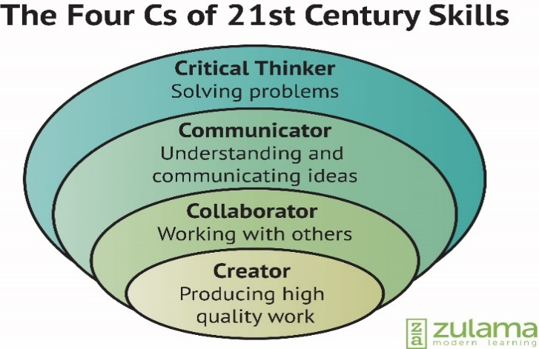
Critical Thinking: Mass devastation often occurs when natural disasters strike. Solve this problem using creative and innovative engineering techniques.
Communication: Work on teams to solve problems, then design & present interesting research.
Collaboration: Work effectively with a group to brainstorm, plan, and implement a design and solution.
Create: Use the engineering process to test new designs that your group creates.

Benchmarks& Due Dates
Benchmark | Due Date | Explanation
Toothpick / Marshmallow House | 8/20/15 | Design & construct an earthquake-proof house made of only marshmallows and toothpicks.
Design research & paper | 9/1/15 | Research disaster-proof structure design and write a one page (single-spaced, 12-point TNR font) essay about design concepts you find. Your Essay should address the following questions:  - What are structural features that can help a building withstand a tsunami, earthquake, landslide, and hurricane / tornado?  - Examples of how / where each feature has been used in the real world.  - Do some features prepare a building for all 4 types of disaster?  - What parts of the world are most affected by each of the natural disasters listed above and what geological, climatological, or geographical features make them so vulnerable to these disasters?
Blue prints for structure | 9/8/15 | The final blue prints should contain scale drawings of 4 elevations (front, back, side, top). The structure should meet the following criteria:  - 2-Story Residential Home  - 1-2 Cubic Feet (Min-Max)  - Wood, Cardboard, Glue, Nails, Screws  - Attached to 1-2 sq ft surface
Paper / Cardboard Prototype | 9/8/15 | Used to test the idea for the scale model.
Disaster Test | 9/22/15 | Will be AWESOME and my disaster simulation methods will remain a mystery until this day.
REAL Natural disaster presentations / fictional essays | 10/8/15 | Teams will research the causes and effects of one of the following natural disasters:  - Hurricane Katrina  - Chile vs. Haiti earthquakes (2010): What happened to cause tragedy vs. minor issues?  - Tsunami (2004) in the Indian Ocean  - Tri-State Tornado (1925)  Teams will create a prezi with the following information:  - Where did it happen?  - The science behind the disaster – how did the weather or geological event happen?  - What was the human impact? (fatalities, injuries, damage, long term consequences)  - One real survivor’s story about what it was like and how it affected their life  - What strategies & innovations could have kept the natural disaster from being so devastating  Each student will write a historically accurate fictional essay or perform a dramatic interpretation about a person who went through one of the natural disasters listed above.  The essay should meet the following criteria:  - One page (single-spaced, 12-point TNR font)  - Reflections on their lives before, during, and after the disaster struck  - Should include some accurate information about the setting and social context of the area and time period  The dramatic interpretation has to meet the following criteria:  - 5-8 minutes in length  - Written transcript of your story  - Memorized lines  - Reflections on their lives before, during, and after the disaster struck  - Historically accurate costume  - Should include some accurate information about the setting and social context of the area and time period

Timeline
August
Monday | Tuesday | Wednesday | Thursday | Friday
17 | 18: Intro to engineering process; toothpick / marshmallow house planning & building | 19 | 20: Marshmallow house tests / redesign | 21
24 | 25: Intro to disaster project; Begin Research phase | 26 | 27: Research & Design | 28
September
Monday | Tuesday | Wednesday | Thursday | Friday
August 31 | 1: Research Papers due; Begin Prototypes | 2 | 3: Prototypes | 4
7: Labor Day | 8: Prototype Tests; Final Blueprints due | 9 | 10: Begin Full scale models | 11
14 | 15: Full Scale Models | 16 | 17: Full Scale Models | 18
21 | 22: Disaster Day | 23 | 24: Gallery Walk | 25
October
September 28 | September 29: Research real natural disasters | September 30 | 1: Research | 2
5 | 6: Research & Writing | 7 | 8: Essay + Presentations due | 9

Groups
Block 1
1 | 2 | 3 | 4 | 5
Trevon | Luke | Cesar | Taylor | Barron
Haley | Chance | Jase | Phillip | Rebecca
Allen | Brenda | Wayde | Khalah | Seth
Karra |  | Miranda | Mack

Block 2
1 | 2 | 3 | 4 | 5
Nathaniel | Haizlee | Beth | Magnus | Will
Madison | AC | Juan | Jake | River
Stephen | Valen | Drake | Haley | Zach
Caleb |  | Chloe | Samuel

